**Child Sponsorship CRM Project**

**Phase 1: Understanding the Problem & Sector Insights**

**Objective**: Build clarity on the purpose of the system and the value it delivers.

**1. Collecting Requirements**

Engage with different stakeholders (program directors, donor management staff, field officers, child welfare teams).

**Sample Needs:**

-> Maintain a record of all sponsored children (personal details, school info, health status).

-> Record sponsor details and track donation history.

-> Link sponsors with one or more children.

-> Provide progress updates and generate impact stories.

-> Track recurring contributions and send reminders.

-> Automate thank-you emails and acknowledgments.

**2. Identifying Key Users**

-> System Administrator → Configures Salesforce, manages permissions.

-> Program Coordinator → Oversees sponsorship program, monitors progress.

-> Donor Relations Staff → Handles sponsor accounts, contributions, and communication.

-> Field Volunteers → Update child status (education, medical, activities).

-> Sponsors → External donors receiving updates through automated emails or reports.

**3. Mapping the Sponsorship Process**

**Typical Flow:**

Sponsor commits a donation → Child assigned to sponsor → Field updates added → Sponsor receives periodic updates/reports → Renewal/reminder cycle initiated.

**4. Sector-specific Considerations**

In child-focused nonprofits:

-> Accountability is crucial → Donors expect clarity on fund usage.

-> Engagement drives retention → Regular communication keeps sponsors involved.

-> Sensitive data → Child details must be protected.

-> Outcome-focused reporting → Organizations must showcase impact (schooling, healthcare, overall development).

Therefore, the CRM solution must:

-> Manage sponsor–child linkages efficiently.

-> Streamline periodic updates and communication.

-> Support recurring donation workflows.

-> Ensure compliance with data protection standards.

**5. Exploring Existing Solutions**

On Salesforce AppExchange, tools like Nonprofit Success Pack (NPSP) already support donor and program management.

These are feature-rich, but for learning purposes, we’ll design a lean, customized system focused only on child sponsorship to practice Salesforce customization.

**Phase 2: Org Setup & Configuration**

**1. Introduction**

The **Child Sponsorship CRM** project is designed to streamline and digitalize the process of managing sponsors, children, and donations within a non-profit context. Phase 2 of the project focused on **Organizational Setup and Basic Configuration** in Salesforce.

This stage laid the foundation by configuring the Salesforce Developer Org, setting up organization information, managing user roles, profiles, and access controls. These steps were essential to establish a secure, role-based environment for future development (custom objects, automation, and analytics).

**2. Objectives of Phase 2**

The key objectives for Phase 2 were:

1. Create and configure a Salesforce Developer Org specifically for the project.
2. Define organizational-level details (name, timezone, currency).
3. Establish basic user management (users, roles, and profiles).
4. Implement a role hierarchy to reflect sponsorship workflows.
5. Define Org-Wide Defaults (OWD) to ensure proper record-level security.

**3. Detailed Activities Performed**

**3.1 Salesforce Developer Org Setup**

* A free **Salesforce Developer Edition Org** was created through [developer.salesforce.com](https://developer.salesforce.com).
* Email verification and login were successfully completed, granting lifetime access to the Org.
* This environment now serves as the sandbox for CRM configuration, testing, and demonstration.

**3.2 Organization Information Configuration**

* **Org Name:** Set to *Child Sponsorship CRM* for identity and consistency.
* **Time Zone:** Configured to match the local region (ensuring accurate timestamps for donations and sponsorship activities).
* **Currency:**
  + INR (for projects operating within India).
  + USD (for international sponsor-focused projects).
* 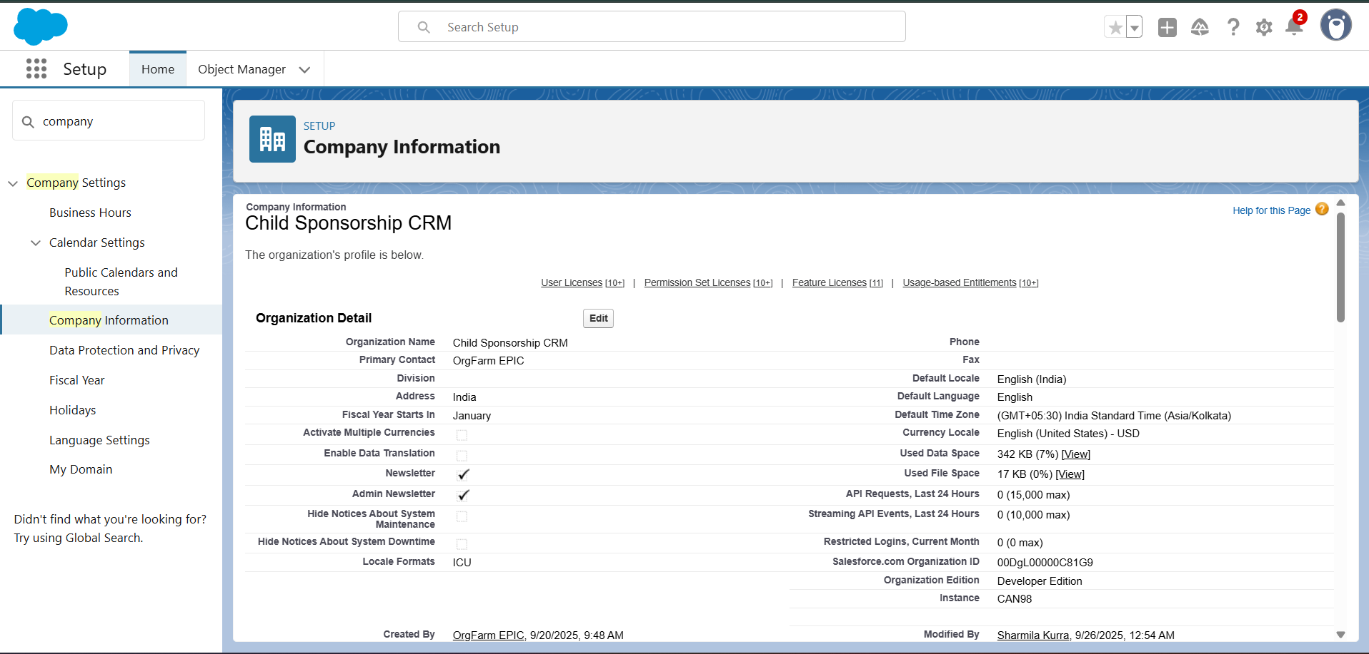These configurations ensure alignment with operational needs and financial reporting accuracy.

**3.3 User Management**

For demonstration purposes, Phase 2 retained a single **System Administrator** user. However, to simulate a real-world scenario, example users were also created to represent different functional roles:

* **Donor Relations Officer:** Responsible for managing sponsor interactions.
* **Volunteer:** Supports on-the-ground data collection and updates.
* **Manager:** Oversees the overall sponsorship program.

This setup enabled testing of role-based access and visibility across the CRM.

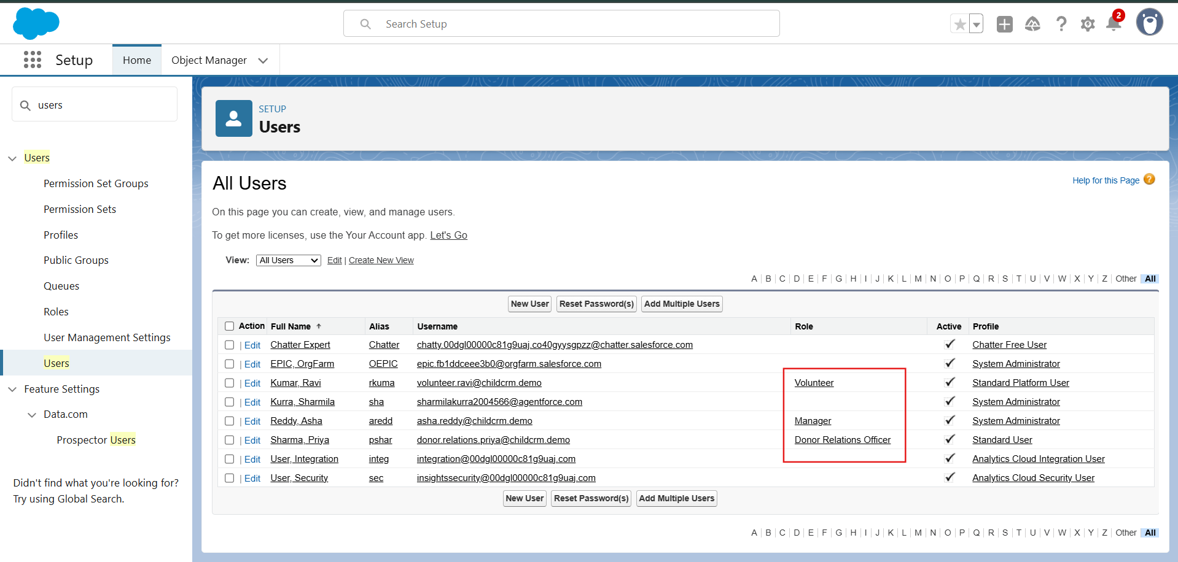

**3.4 Profiles (Access Control)**

Profiles in Salesforce determine what actions a user can perform.

* **System Administrator (Admin Account):** Granted full access to all features, objects, and data.
* **Standard User (Volunteers):** Restricted access with basic permissions to view and update records.

Custom profiles were not created at this stage to maintain simplicity, but the structure allows for future expansion.

**3.5 Roles and Role Hierarchy**

Roles define **data visibility** in Salesforce, ensuring managers can view records owned by their subordinates. A hierarchical structure was created:

* **Manager** (Top Role)
* **Donor Relations Officer** (Reports to Manager)
* **Volunteer** (Reports to Donor Relations Officer)

This role structure reflects real-world operations in sponsorship organizations where managers supervise donor officers, who in turn oversee volunteers.

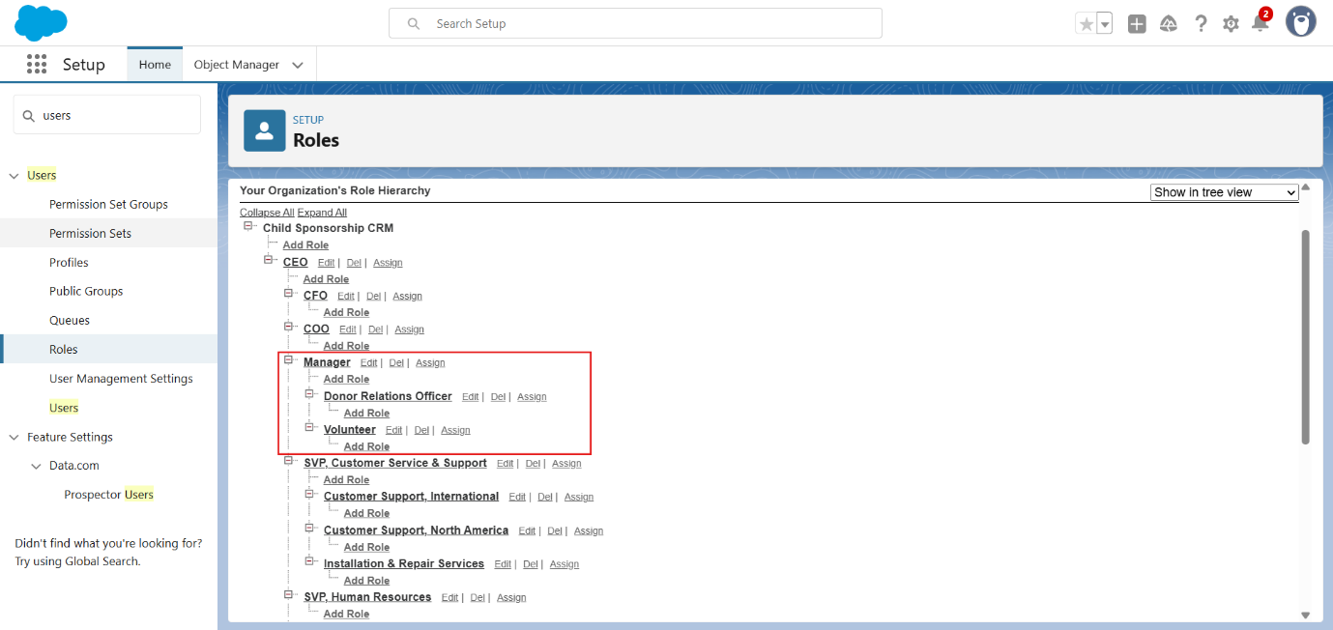

**3.6 Org-Wide Defaults (OWD)**

Org-Wide Defaults (OWD) establish the **baseline level of access** for all records.

The following security model was applied:

* **Child Records:** Public Read/Write (all users can view and update child records).
* **Sponsor Records:** Public Read/Write (all users can view and update sponsor records).
* 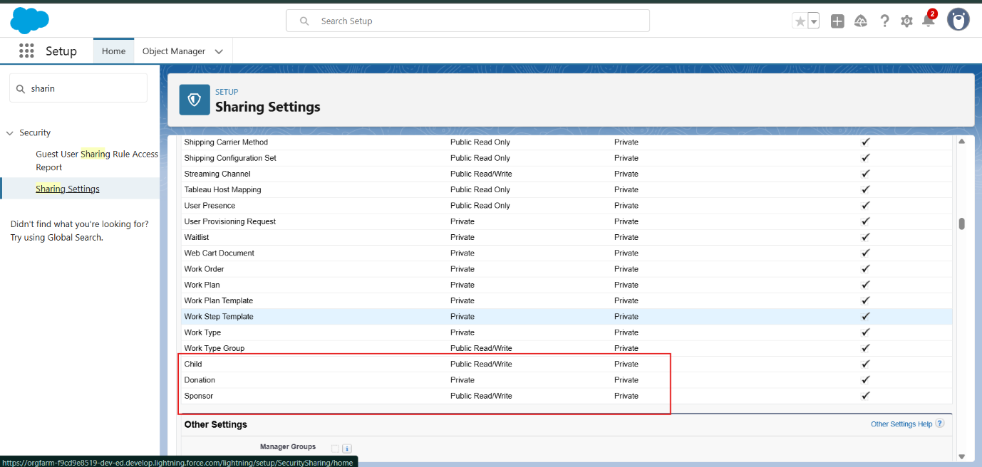**Donation Records:** Private (only the record owner and their manager can view/edit donation data).

**4. Key Outcomes**

At the end of Phase 2, the following deliverables were achieved:

1. Salesforce Developer Org successfully configured and ready for use.
2. Organizational information tailored to project needs (branding, currency, timezone).
3. User management simulated with Admin, Donor Officer, Volunteer, and Manager roles.
4. Profiles established for differentiated access (Admin vs. Standard User).
5. Role hierarchy defined to support real-world reporting structures.
6. Record-level security implemented using OWD to protect donation confidentiality.

**5. Challenges and Resolutions**

* **Challenge:** Understanding the difference between Profiles and Roles.
  + **Resolution:** Profiles control what actions users can perform, while Roles control which records they can see. This distinction was documented for clarity.
* **Challenge:** Balancing collaboration vs. confidentiality.
  + **Resolution:** Donations were kept **Private**, while Child and Sponsor records were **Public Read/Write**, enabling both data sharing and protection.

**6. Conclusion**

Phase 2 successfully delivered a well-structured Salesforce Org with defined access controls, user roles, and record-level security. These configurations create a strong foundation for subsequent phases, ensuring that when custom objects and automation are introduced, the system remains secure, scalable, and aligned with organizational needs.

**Phase 3: Data Modeling & Relationships**

**1. Introduction**

Phase 3 of the **Child Sponsorship CRM** project focused on **Data Modeling and Relationships** within Salesforce. This stage established the core data structure by creating objects, defining fields, and modeling relationships between children, sponsors, and donations. The goal was to design a logical, scalable schema that supports real-world sponsorship operations and ensures seamless tracking of records.

**2. Objectives of Phase 3**

The specific objectives were:

1. Create custom objects for **Child**, **Sponsor**, and **Donation**.
2. Define key fields for each object to capture sponsorship-related information.
3. Establish relationships (lookups) between objects to enable record linkage.
4. Customize page layouts for user-friendly record management.
5. Configure compact layouts for mobile usability.
6. Use Schema Builder to visualize and validate the data model.

**3. Detailed Activities Performed**

**3.1 Object Creation**

* **Standard Object (Optional):** *Contact* was considered as an alternative to a custom Sponsor object but not used for this demo to keep design simple.
* **Custom Objects Implemented:**
  1. **Child** – tracks children eligible for or under sponsorship.
  2. **Sponsor** – maintains donor information.
  3. **Donation** – records financial contributions.

This three-object model was chosen to provide a clear, minimal structure that still captures all critical data.

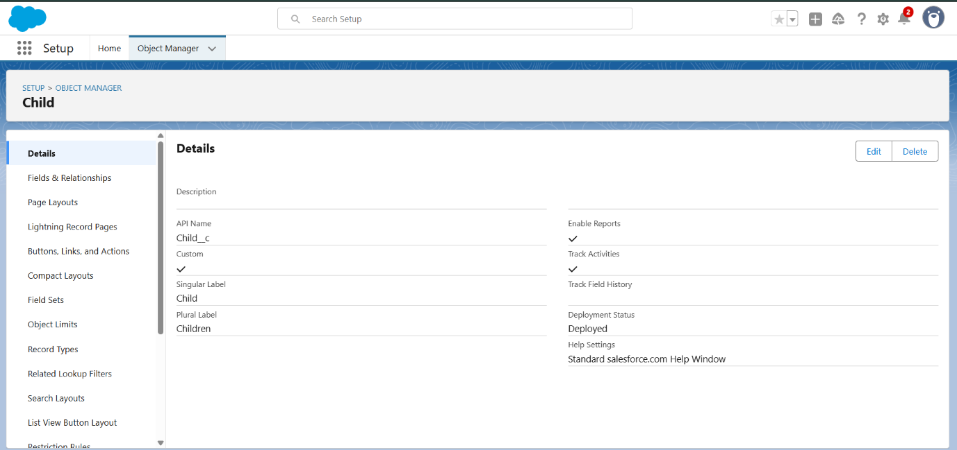

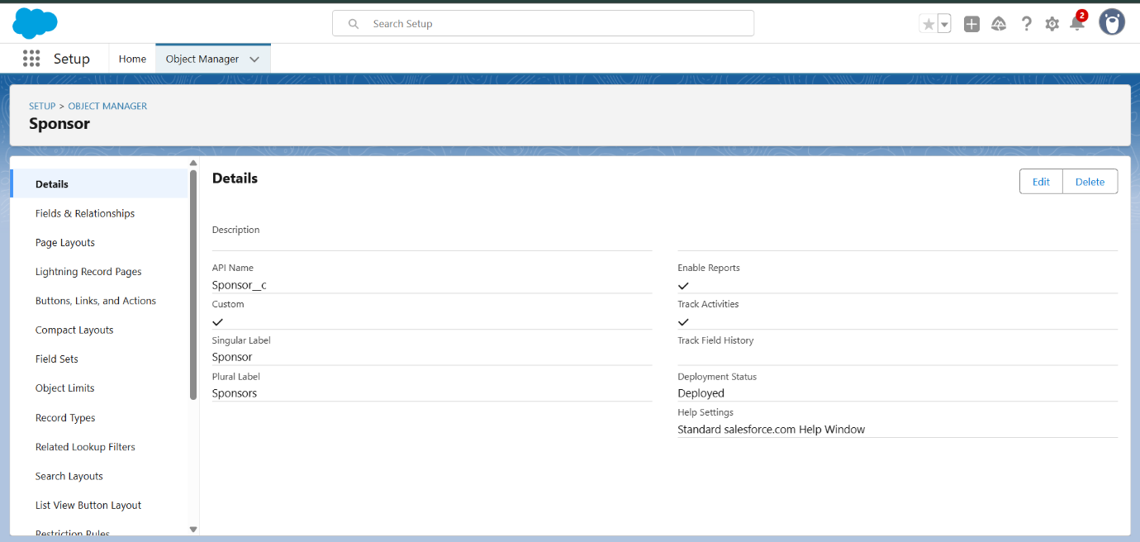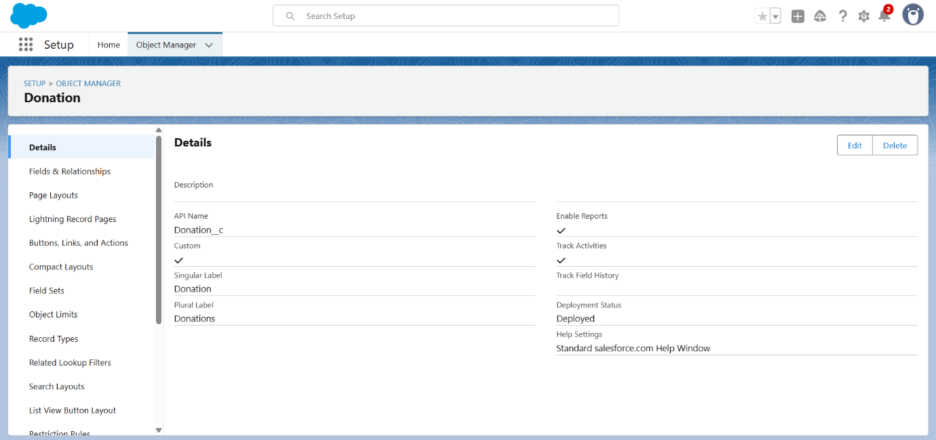

**3.2 Field Definitions**

**Child Object**

| **Field** | **Type** | **Notes** |
| --- | --- | --- |
| Name | Auto Number or Text | Unique identifier for child |
| Age | Number | Tracks child’s age |
| Gender | Picklist | Values: Male, Female, Other |
| Progress Notes | Long Text Area | Narrative updates about the child |
| Assigned Volunteer | Lookup (User) | Links child to a volunteer (optional for demo) |

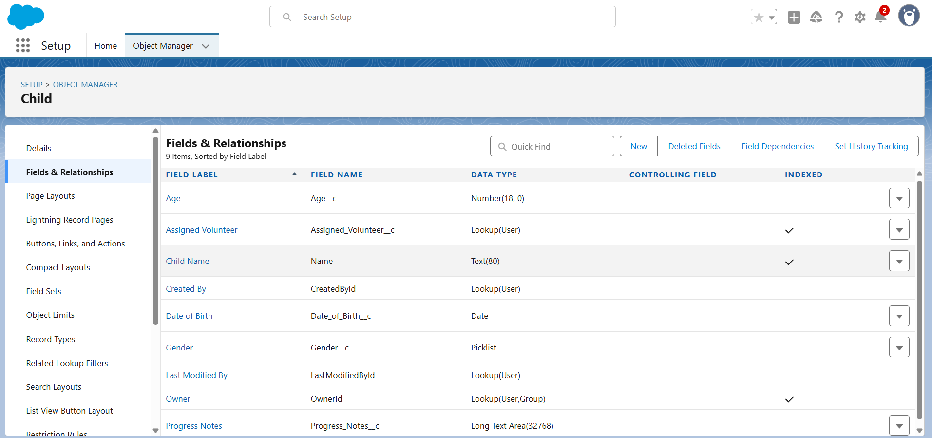

**Sponsor Object**

| **Field** | **Type** | **Notes** |
| --- | --- | --- |
| Name | Text | Full name of sponsor |
| Email | Email | Contact email for communication |
| Phone | Phone | Optional contact field |
| Assigned Officer | Lookup (User) | Donor Relations Officer responsible for sponsor |

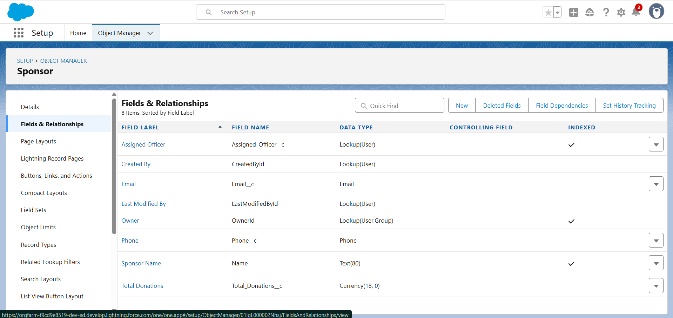

**Donation Object**

| **Field** | **Type** | **Notes** |
| --- | --- | --- |
| Name | Auto Number (DON-{0001}) | Unique donation identifier |
| Amount | Currency | Donation value |
| Date | Date | Date of donation |
| Sponsor | Lookup (Sponsor) | Links donation to sponsor |
| Child | Lookup (Child) | Links donation to sponsored child |
| Notes | Long Text Area | Optional additional information |

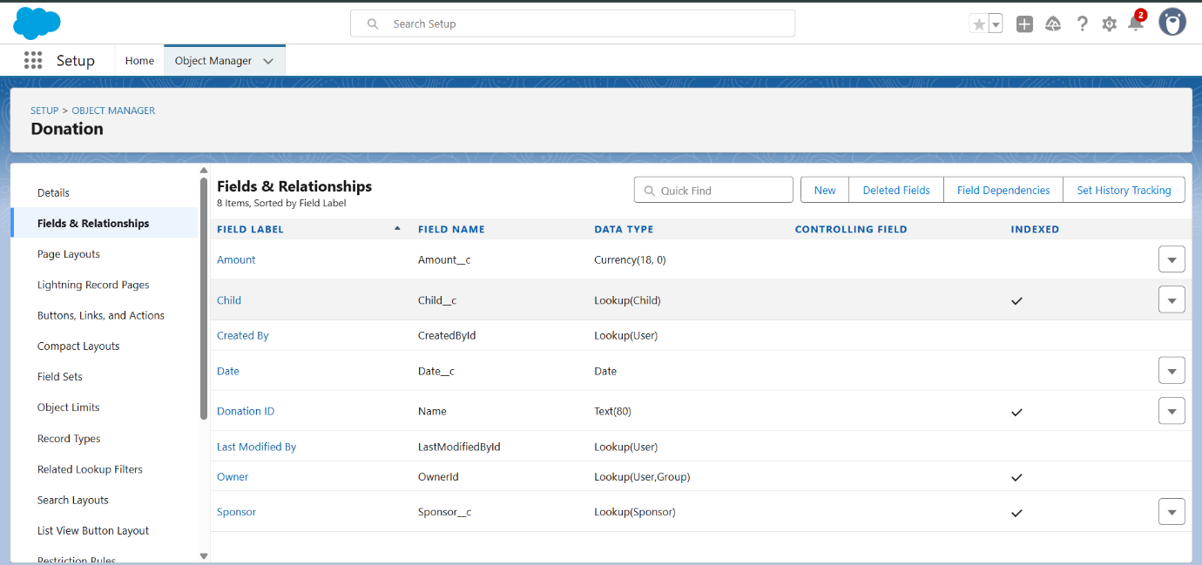

**Field Creation Steps (General):**

* Setup → Object Manager → [Object] → Fields & Relationships → New.
* Choose field type (e.g., Text, Number, Lookup).
* Enter Field Label (Field Name auto-fills).
* Configure field-level security (visibility for profiles).
* Add to relevant page layouts.

**3.3 Page Layouts**

Page layouts were designed to display the most relevant information and related records.

* **Child Page Layout:** Includes fields (Age, Gender, Progress Notes, Assigned Volunteer) and related list for Donations.
* **Sponsor Page Layout:** Includes fields (Email, Phone, Assigned Officer) and related list for Donations.
* **Donation Page Layout:** Shows Donation details (Amount, Date) with linked Child and Sponsor fields.

**Steps:**  
Setup → Object Manager → [Object] → Page Layouts → Edit → Drag-and-drop fields and related lists.

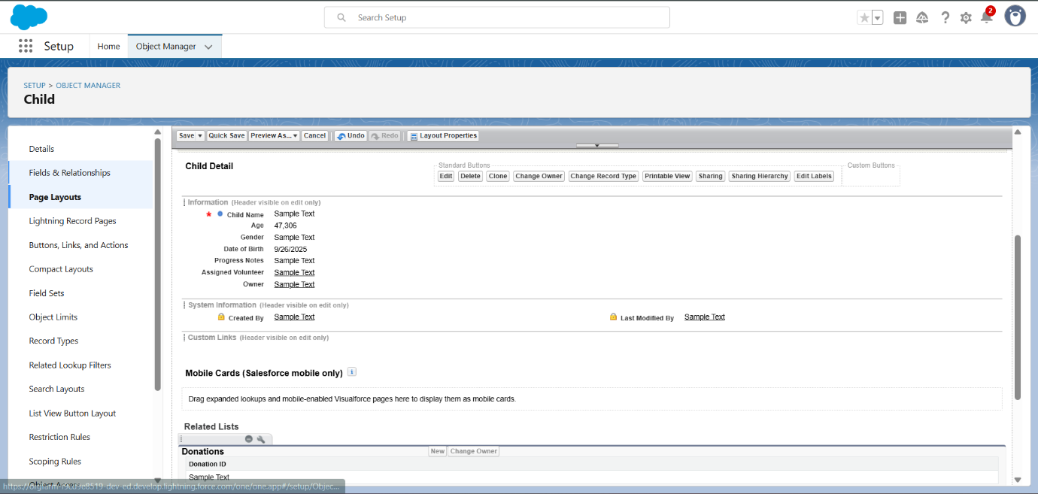

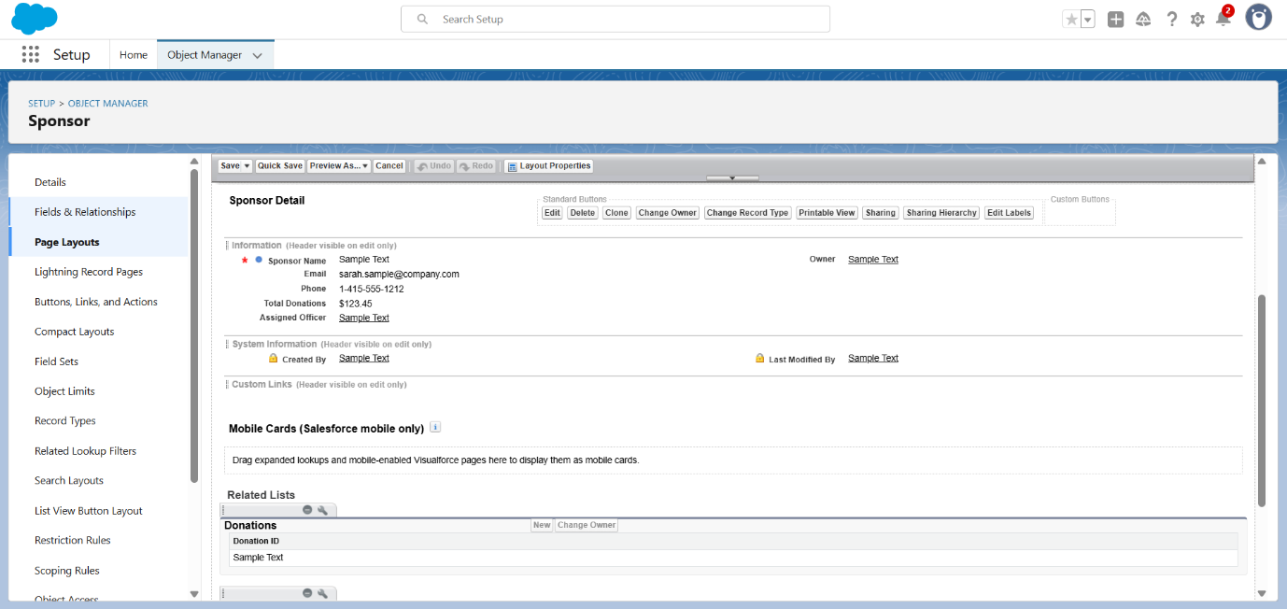

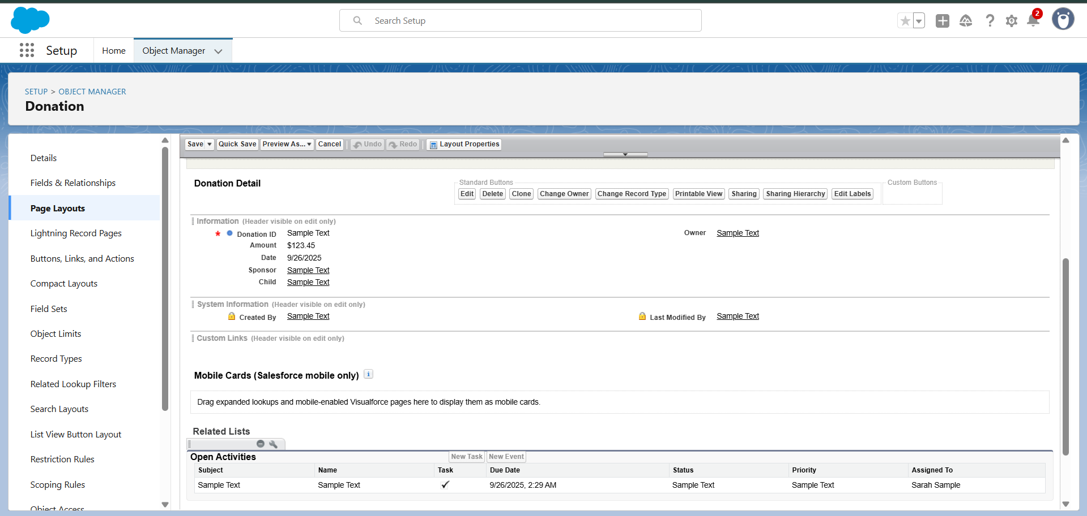

**3.4 Compact Layouts**

Compact layouts were created for mobile-friendly record views:

* **Child Compact Layout:** Displays Name, Age, and Gender.
* **Sponsor Compact Layout:** Displays Name, Email, and Phone.
* **Donation Compact Layout:** Displays Donation Name, Amount, and Date.

**Steps:**  
Setup → Object Manager → [Object] → Compact Layouts → New → Select fields → Save.

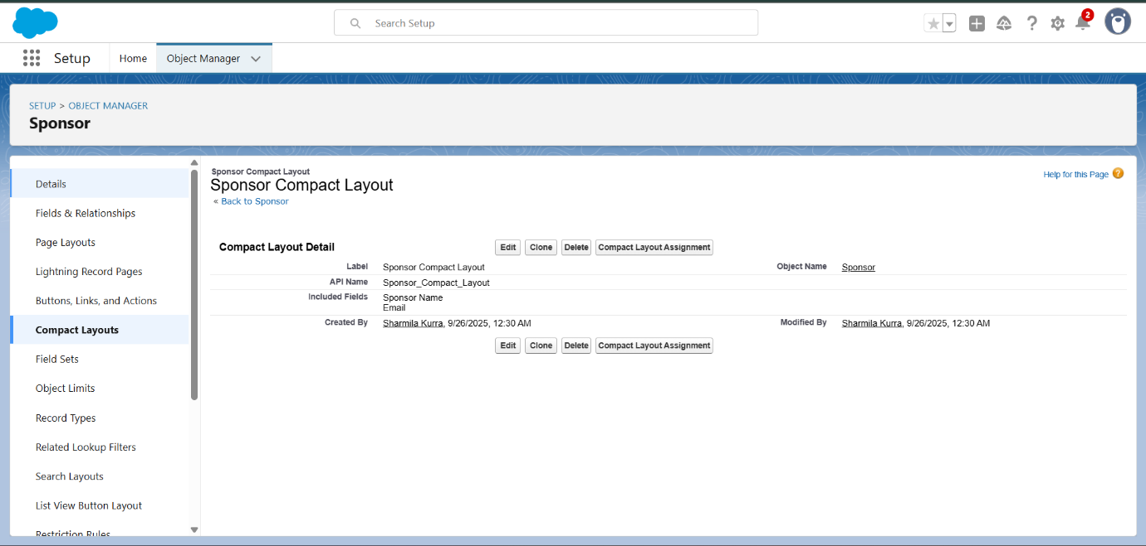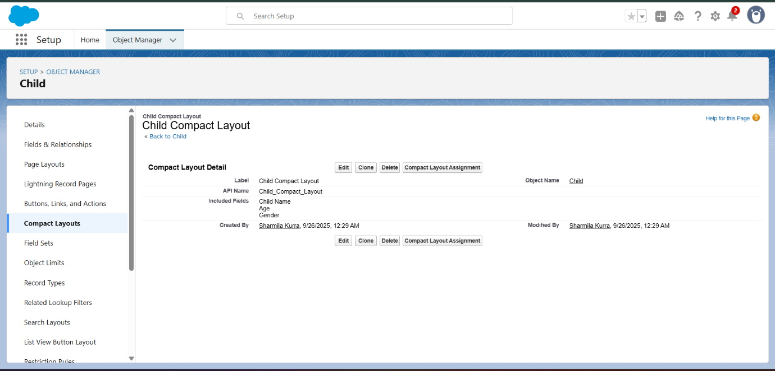

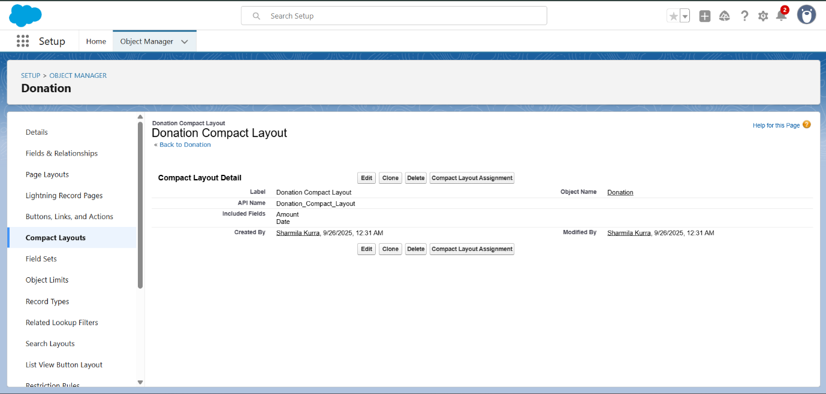

**3.5 Schema Builder**

The Salesforce **Schema Builder** was used to visualize and confirm object relationships:

* Dragged **Child**, **Sponsor**, and **Donation** objects into the canvas.
* Verified lookup relationships:
  + Donation → Sponsor
  + Donation → Child
* Ensured schema shows a clear many-to-one structure (one Sponsor can have multiple Donations; one Child can be linked to multiple Donations).

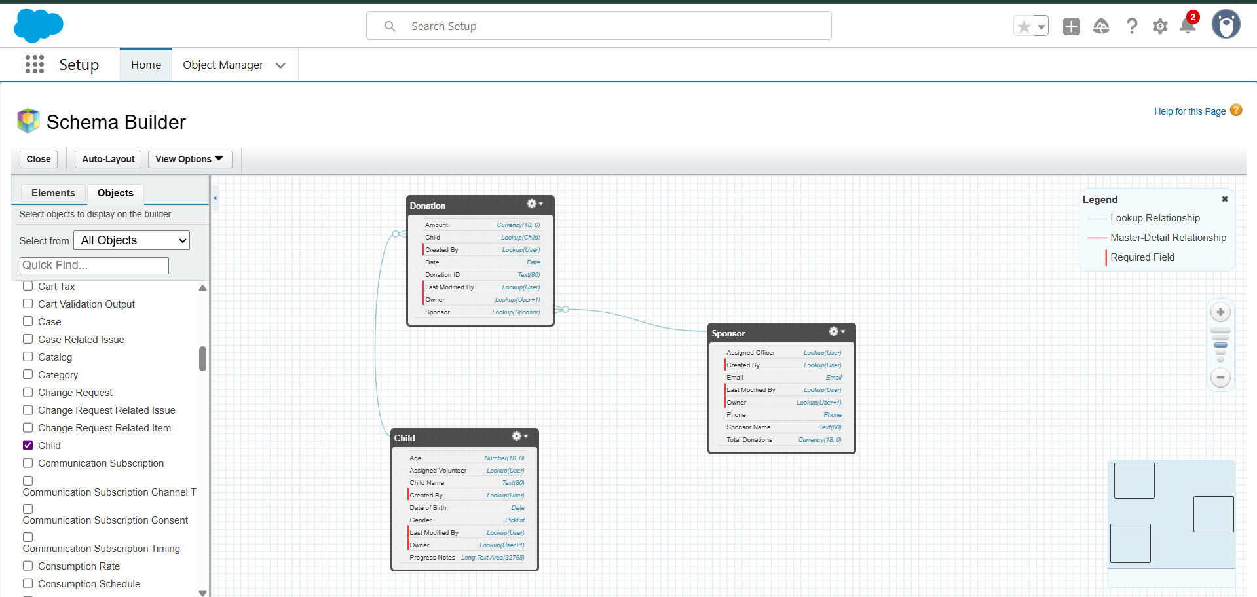**Steps:**  
Setup → Schema Builder → Select objects → Drag to canvas → Save schema view.

**4. Key Outcomes**

* Custom objects **Child, Sponsor, Donation** successfully created.
* All relevant fields configured with appropriate data types.
* Page layouts customized for intuitive record management.
* Compact layouts configured for enhanced mobile usability.
* Schema Builder visualization confirmed correct relationships between objects.

**5. Challenges and Resolutions**

* **Challenge:** Deciding whether to use standard *Contact* or a custom Sponsor object.
  + **Resolution:** Chose a custom Sponsor object to maintain clarity and project-specific control.
* **Challenge:** Designing relationships without overcomplicating schema.
  + **Resolution:** Kept only essential lookup relationships (Donation ↔ Child, Donation ↔ Sponsor) to avoid redundancy.

**6. Conclusion**

Phase 3 successfully delivered the **data modeling foundation** for the Child Sponsorship CRM. By designing objects, fields, relationships, and layouts, the project now has a robust and scalable data structure that reflects real-world sponsorship workflows. This foundation will enable smooth automation and analytics in subsequent phases.